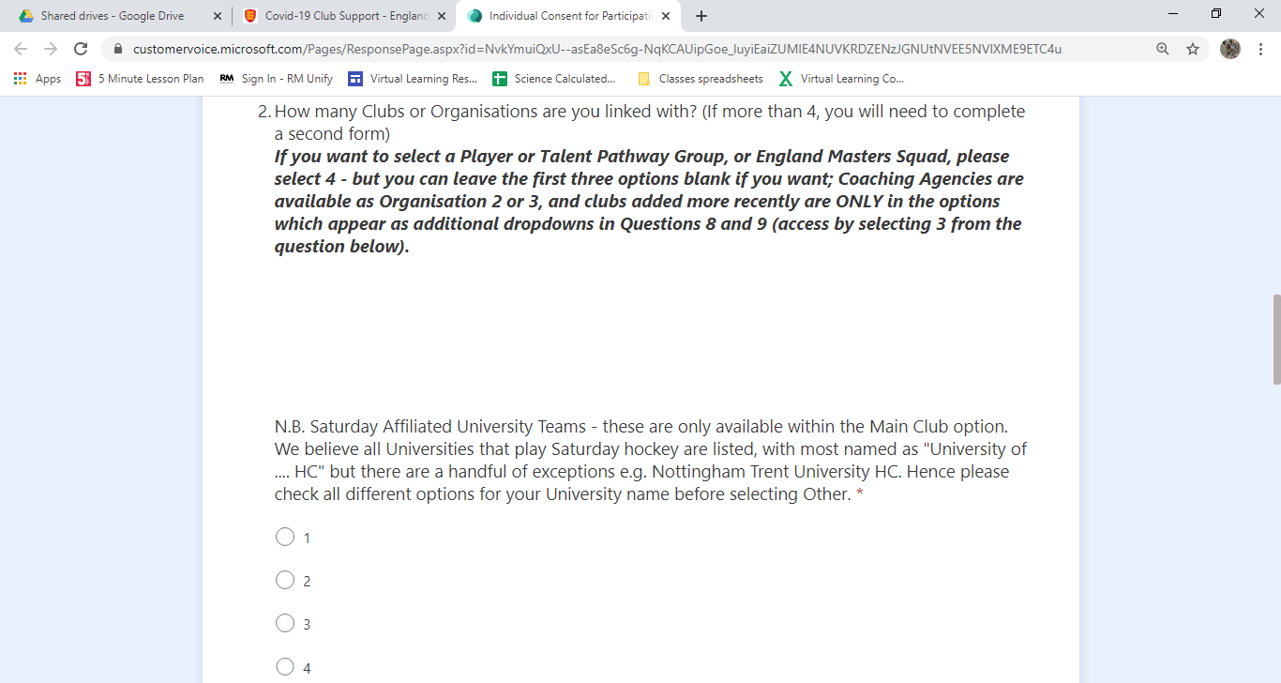**Instructions for filling in the England Hockey Club Participation Agreement**

**You will need to select box 3 from this list.**

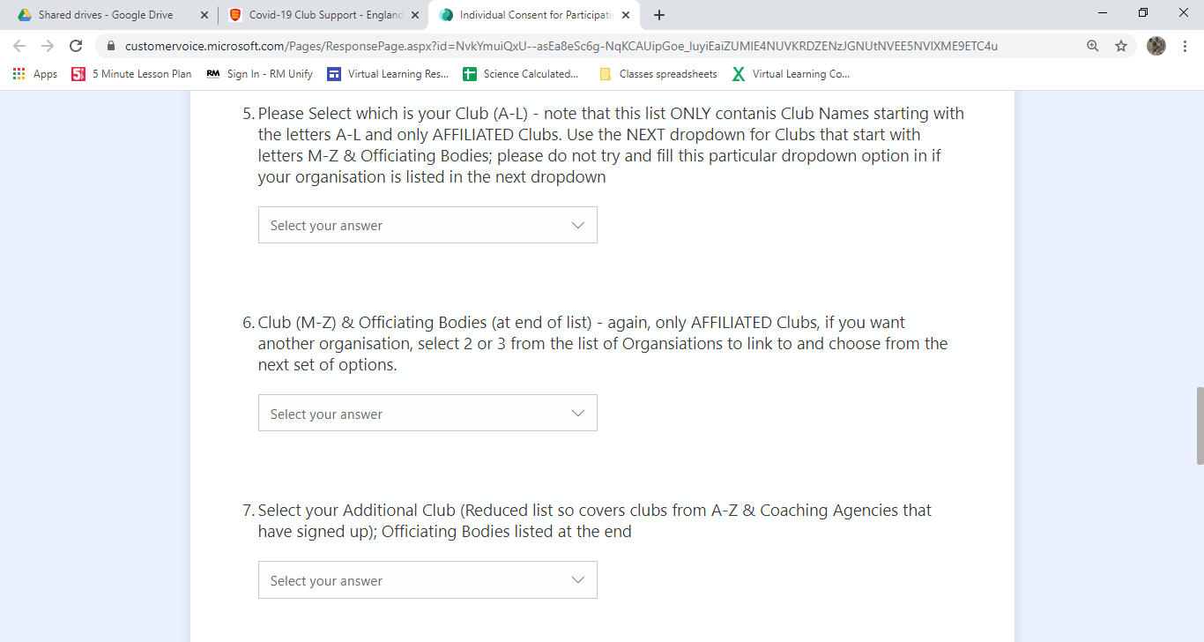

**This box / question 9 should now appear and we should be in this drop down**

